Document 3

Kepler 62 System

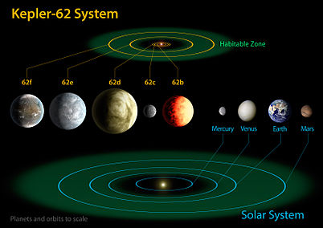The planets orbiting the star Kepler 62 were discover earlier in the year 1,200 light-years from earth by NASAs kepler mission via the transit method. Not much information is known about the planets orbiting the star kepler 62 because of the low masses and close formation of the planets. This means that the planets have very little gravitational pull on the star so do not cause it to ‘wobble’. However what we do know very certainly is the planets orbital period, eccentricity and argument of periastron as the transit method can tell us this very clearly. The print screen below from exoplanets.org show how uncertain the rest of the planets orbital variables can be.

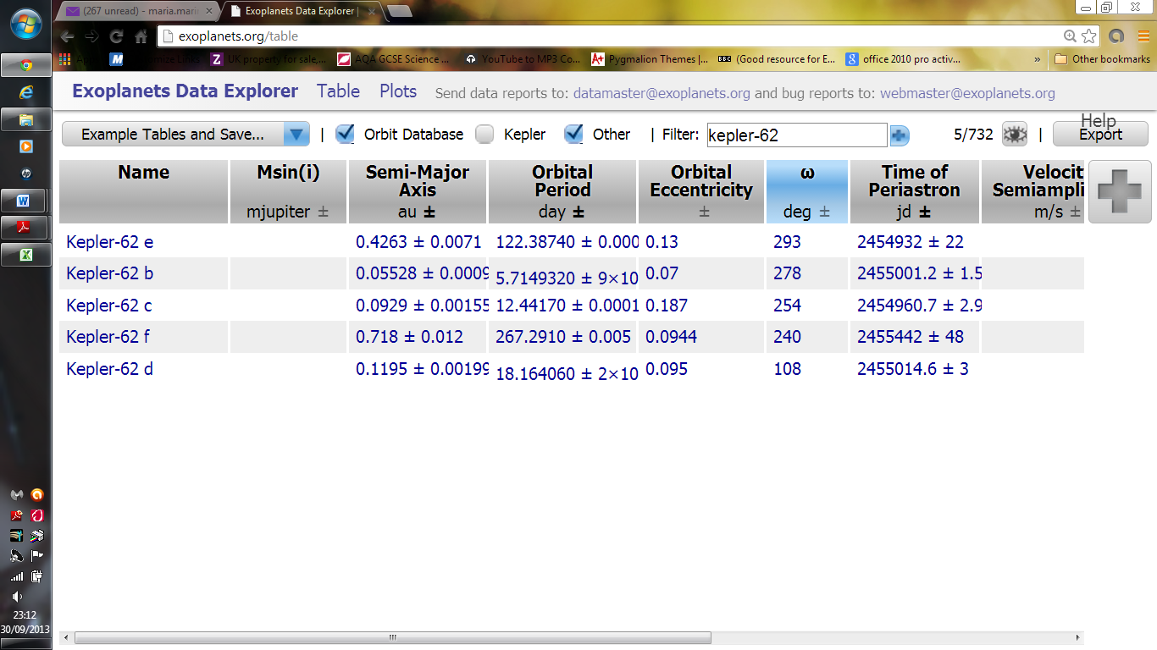These planets are particularly interesting because two of the five planets are known to be in the habitable zone meaning the planets are far enough from the sun for the water to remain liquid. Many scientists believe that the planets kepler-62 e and f the outer most planets are the most earth like planets yet found the picture above shows that the two planets are ver close to the size of earth they are believed to both be rocky dense planets.

Kepler-36 System

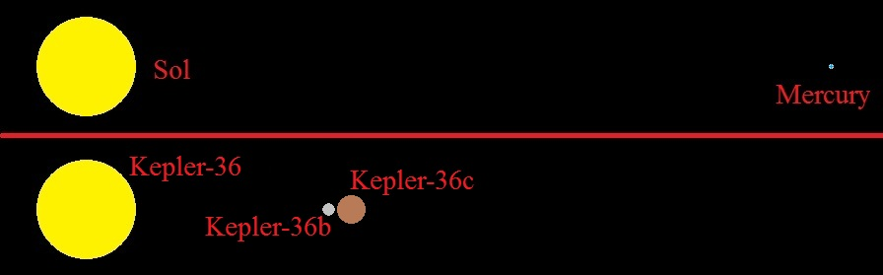The discovery of two planets orbiting the star kepler-36 was announced. The planets are described as a super-Earth and a "mini-Neptune" however the reason we are looking at these two planets is not because they lie in the habitable zine or are earth like. It is because the two planets have a very distict affect on eachother with we belive may one day cause one of the planets to be throne out of orbit; their semi-major axes differ by only 0.013 astronomical units, meaning that their interaction causes there orbits to vary massivly and be unsable.Kepler-36b and c have estimated densities of 6.8 and 0.86 g/cm3, respectively. One has the power to pull the other and we want to investigate this. The image to theside shows the relative proximity of the planets compared to the proximity of the sun and mercury.

Kepler-36: A Pair of Planets with neighbouring Orbits and Dissimilar Densities

<http://www.sciencemag.org/content/340/6132/587.short>

The Inner Structure of the Planets Kepler-62 e and Kepler-62 f R.-S.Taubner

Borucki, W. J. et al.: Kepler-62: A Five-Planet System with Planets of 1.4 and 1.6 Earth Radii in the Habitable Zone, Science Express.

<http://gscim.com/Science_News/6-12/amazingly_close_planets.html>